Feast Pattern Optimization Notes and Summary

Overview
This document summarizes our discussion of the multiperson feast passing pattern, the mathematical model used to optimize the juggler motion, and selected numerical findings.
The main modeling goals were:
- keep each juggler near a home position on a regular $n$-gon,
- keep passing distances comfortable,
- avoid overlap of the 3-foot-radius personal discs,
- encourage smooth motion between beats, and
- exploit the rotational symmetry of the feast by using a single master trace for all jugglers.
The summary tables below use the symmetry-constrained single-trace model for $n=8,10,12,14,16,18,20$.

Feast pairing rule
Index jugglers by $i=1,…,n$, and index passing beats by $t=0,1,…,n−1$. On beat $t$, juggler $i$ pairs with
$$j\left(i,t\right)=1+\left(\left(t−i\right)modn\right).$$
If $j\left(i,t\right)=i$, that beat is a phantom pass for juggler $i$. This produces a noncrossing round-robin pattern in which each juggler eventually passes to every other juggler once, plus one phantom.

Symmetry reduction: one shared trace
The main improvement for larger $n$ was to enforce symmetry directly. Instead of optimizing all jugglers independently, I optimize a single closed trace $q_{k}∈R^{2}$ for $k=0,…,n−1$, expressed in local coordinates relative to a home base.
All other jugglers are generated by rotation and time shift:
$$x_{i}\left(t\right)=R​\left(−\frac{2π\left(i−1\right)}{n}\right)q_{t−2\left(i−1\right)modn},$$
where $R\left(θ\right)$ is the planar rotation matrix. This reduction changes the optimization from $2n^{2}$ variables to only $2n$ variables. For example, for $n=20$ the number of optimized coordinates drops from 800 to 40.

Objective function
The model uses a weighted sum of penalties. Let $R$ denote the home-circle radius and let $q_{k}=\left(u_{k},v_{k}\right)$, where $u_{k}$ is radial position and $v_{k}$ is tangential position in the juggler’s local frame. A convenient objective is:
$$E\left(q\right)=E_{home}+E_{move}+E_{accel}+E_{throw}+E_{coll}.$$

1. Home-position penalty
Radial motion was taken to be easier than sideways motion, so I used an anisotropic home penalty:
Ehome=αrk​uk−R2+ατk​vk2,
with $α_{τ}>α_{r}$. In the main symmetric runs the values were approximately $α_{r}=0.08$ and $α_{τ}=0.50$.

2. Beat-to-beat motion penalty
Emove=ηk​∥qk−qk−1∥2.
This discourages large jumps between consecutive passing beats.

3. Smoothness / acceleration penalty
Eaccel=κk​qk+1−2qk+qk−12.
This favors smooth closed traces rather than polygonal or kinked ones.

4. Throw-distance penalty
At each passing beat, if two jugglers in a pair are distance $d$ apart, the original soft penalty was
$$P_{throw}\left(d\right)=β{\left(d−6\right)}_{+}^{2}+Γ{\left(d−12\right)}_{+}^{2},$$
where ${\left(z\right)}_{+}=max\left(z,0\right)$. This encourages throws shorter than 6 ft and makes throws above 12 ft very expensive. This choice led to the first family of “beautiful” symmetric solutions with longest pass under about 8 ft.
Later, for the $n=20$ trade-off experiment, I replaced the first threshold by 10 or 11 feet to better reflect your practical experience that throws are comfortable up to about 10–12 ft and deteriorate mainly beyond 12 ft.

5. Collision penalty
Let $d_{ab}\left(s\right)$ be the distance between jugglers $a$ and $b$ at a sampled time $s$ along the smooth motion between beats. With 3-ft personal radii, center-to-center spacing should stay at or above 6 ft, so I used
Ecoll=λs,a<b​ℓ−dabs+2,
with a target clearance $ℓ≈6.18$ ft in the symmetric code. The 6.18-ft value was a small buffer so that dense sampling would still keep the realized minimum separation very near 6 ft.

Optimization method
The numerical optimization was carried out in Python with SciPy’s scipy.optimize.minimize(..., method="L-BFGS-B"). Important implementation details:
- the reduced variables are the $n$ key points of the single master trace,
- analytic gradients were supplied for the objective,
- periodic cubic interpolation was used to create a smooth trace from the discrete beat positions,
- collision penalties were sampled at several intermediate times between beats,
- several smooth initial guesses were tried for the single-trace model, and
- solutions were checked afterward by denser sampling to estimate minimum separation.
This is a local optimization method, not a proof of global optimality, so initialization matters. In particular, the symmetry-constrained model gave much more reliable and believable answers than the unconstrained $2n^{2}$-variable model for larger $n$.

Numerical findings for $n=8$ to $n=20$
The table below reports the recomputed length of the optimal smooth master trace for each even $n$ from 8 to 20, together with selected other metrics. The trace length is the distance traveled by the center of one juggler’s disc over a full cycle.
n | Trace length (ft) | Spin (rad) | Spin (deg) | Longest pass (ft) | Largest step between beats (ft) | Minimum sampled separation (ft) | Home radius (ft)
8.000 | 17.582 | 4.712 | 270.000 | 7.761 | 2.837 | 6.168 | 9.146
10.000 | 26.058 | 5.027 | 288.000 | 7.802 | 3.273 | 6.173 | 11.326
12.000 | 34.390 | 5.236 | 300.000 | 7.810 | 3.729 | 6.175 | 13.523
14.000 | 42.667 | 5.386 | 308.571 | 7.809 | 4.073 | 6.176 | 15.729
16.000 | 50.617 | 5.498 | 315.000 | 7.796 | 4.638 | 6.161 | 17.940
18.000 | 57.961 | 5.585 | 320.000 | 7.785 | 4.911 | 6.158 | 20.156
20.000 | 65.246 | 5.655 | 324.000 | 7.769 | 4.967 | 6.155 | 22.374
Two patterns stand out:
- The trace length grows significantly with $n$.
- The spin grows much more slowly, and in these symmetric solutions follows
$$S\left(n\right)=2π\left(1−\frac{2}{n}\right).$$
- This gives 270° for $n=8$, 288° for $n=10$, …, up to 324° for $n=20$.
The figure below compares the optimized master traces across the range of $n$ values.
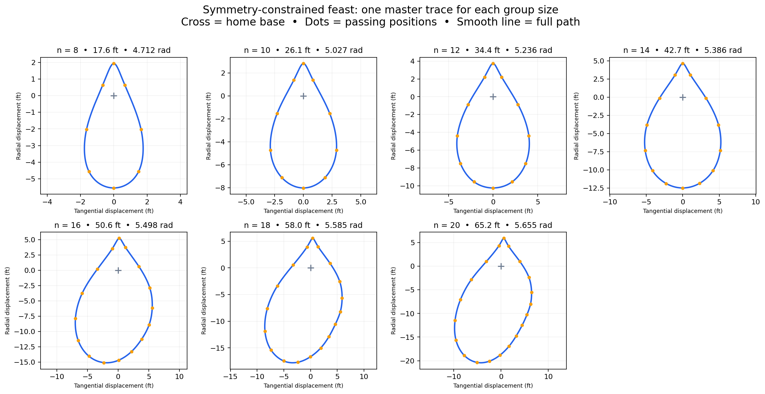
Comparison of master traces for feast patterns with $n=8$ through $n=20$.

Notes on the spin metric
For each actual pass, define the facing angle of juggler 1 by the angle from juggler 1 to their partner:
$$θ_{t}=atan2\left(y_{j}−y_{i}, x_{j}−x_{i}\right).$$
The spin is the sum of absolute wrapped changes in this facing direction from one actual pass to the next, including the wrap from the last pass back to the first pass in the next cycle:
S=t​Argeiθt+1−θt.
Phantom beats are skipped in this accumulation. In practice, this measures the total amount a juggler must turn to keep “squaring up” to successive passing partners.

Reworking the $n=20$ case to allow longer passes
Your practical observation was that feast patterns work well when pass lengths are allowed up to about 10–12 ft, but deteriorate quickly beyond 12 ft. That suggested modifying the throw penalty so the optimizer would not work so hard to shorten already-manageable throws.
The next table compares several $n=20$ scenarios.
Scenario | Trace length (ft) | Longest pass (ft) | Mean pass (ft) | Largest step between beats (ft) | Minimum sampled separation (ft)
Original 6-ft soft threshold | 65.246 | 7.769 | 6.793 | 4.967 | 6.155
10-ft soft threshold | 55.647 | 11.112 | 10.146 | 4.433 | 6.174
11-ft soft threshold | 54.224 | 11.989 | 10.957 | 4.279 | 6.178
Free to 10 ft | 53.789 | 12.015 | 11.231 | 4.286 | 6.176
This trade-off study shows that allowing longer passes in the 10–12 ft range can materially reduce the total walking distance per cycle while retaining a symmetric, smooth choreography.
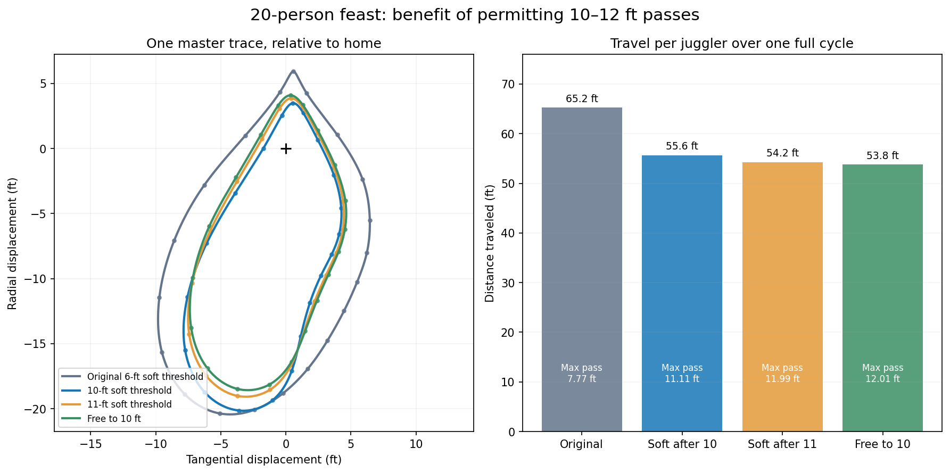
Comparison of $n=20$ trade-off solutions under different throw-distance preferences.
A practical takeaway is that the original 6-ft soft threshold created very elegant solutions, but also more walking than may be necessary. For larger $n$, a gentler throw penalty beginning near 10 ft is probably a better reflection of real passing practice.

Concluding remarks
The single-master-trace formulation seems to be the right mathematical description of the feast when one wants symmetric and realistic solutions. It gives:
- a dramatic reduction in optimization dimension,
- much more believable solutions for larger $n$,
- easy comparison across different group sizes, and
- a clean way to study trade-offs between throw length, walking distance, and smoothness.
Natural next refinements would be:
- adding an explicit penalty on peak speed or peak acceleration, not just total movement,
- sampling even more densely (or constraining analytically) to guarantee non-overlap throughout the motion,
- tuning throw thresholds and weights from practical juggling experience, and
- comparing 4-count, 8-count, and slower patterns by normalizing movement to distance per club release rather than only distance per cycle.

Files included / referred to in this report
- feast_8_to_20_metrics.csv
- feast_trace_length_recomputed.csv
- feast_8_to_20_trace_comparison.png
- feast_20_throw_tradeoff_metrics.csv
- feast_20_throw_tradeoff_comparison.png
- feast_single_trace_model.py
- feast_20_longer_passes.gif
- feast_20_symmetric.gif

